Create scp user which should have no privileges to do ssh

Login the server

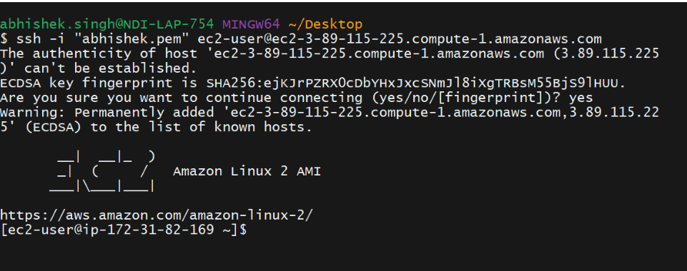

Created a new user abhishek

Then Modified sshd_config file to allow ssh to user abhishek and restart sshd service

sudo vi /etc/ssh/sshd_config

AllowUsers abhishek

sudo systemctl restart sshd

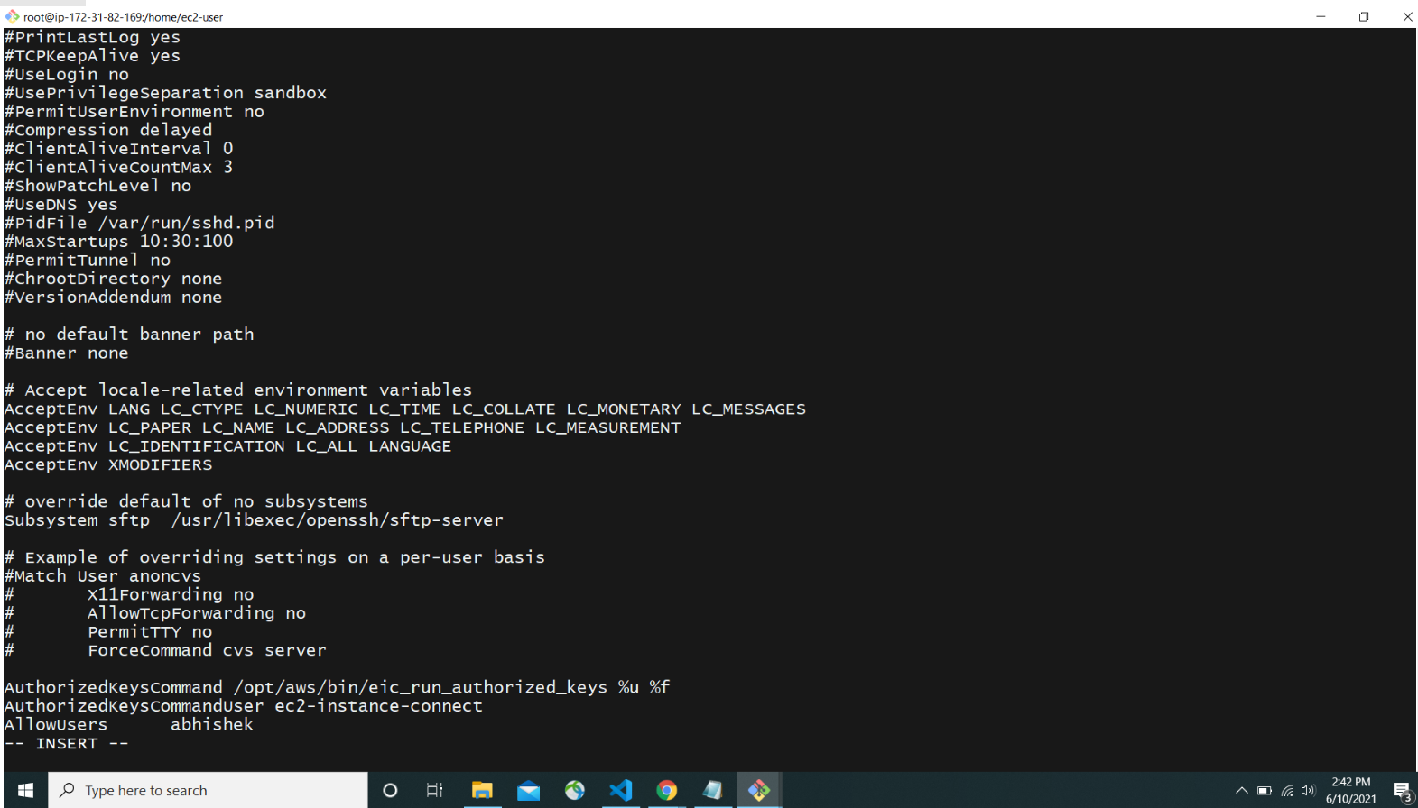

User is able to ssh, Now remove the ssh permission and again restart the service.

sudo vi /etc/ssh/sshd_config

DenyUsers abhishek

sudo systemctl restart sshd

